VIA NOVA CHILDREN’S SCHOOL
TUITION PAYMENT AND FEES
Tuition for August 9th, 2023, to July 26th, 2024

2 years old/Roly Polies 5 days/week $28,500 year, in monthly installment of $2,375

3 years old/Grasshoppers 5 days/week $27,132 year, in monthly installment of $2,261
4 years old/Dragonflies 5 days/week $27,132 year, in monthly installment of $2,261

Tuition payments are due on the first day of each month with a five-day grace period before payments are considered late. If paying after the 5th of the month, please add the late fee of $20.00 to your total. A $25.00 fee will be charge for returned checks.

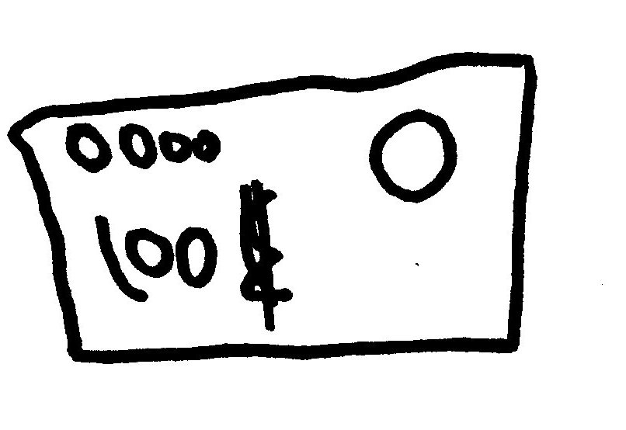
One Time and Annual Fees:
Application Fee $50.00
Last Month Deposit Equal to one month’s tuition
Annual Earthquake Fee $25.00
Yearly Material Fee $300.00
Late Pick-up Fee $1 each minute
Late fee for Monthly Tuition $20.00 after the 5th of the month
Return Check $25.00

Direct Deposit information:
Via Nova Children’s School
Mechanics Bank
Checking accnt. no. new 3505406925
Rounting no. 121102036

